horizontal line

**Takouba**

Veterans Affairs

Modeling to Learn  
System Dynamics Platform   
(to Increase Timely Access to VHA Evidence-based Outpatient Mental Health Care)

**Design Document -- MTL Version 1.6**

Monday, 6 August, 2018  
Version 1

horizontal line

# Document History & Status

|  |  |  |
| --- | --- | --- |
| Version | Date | Description/ Status |
| v 1 | 8 August 2018 | Start of Document / Development. |
|  |  |  |
|  |  |  |
|  |  |  |



**Table of Contents (Quick Link)**

Document History & Status

Objective of This Document

Basics

Objectives

Schedule

Current Vensim Models in Use

Design Features

Save Experiment Slider Settings.

Provide Advanced Chart Management in Drop Down Menus

Provide File Management Functions for Saved Sessions

Provide Bold-face on Lines for Experiment Values Changed from Default

Provide Fields to Gather Metadata and Use to Make Session Name

Provide an Error-proofed Way to Create Session Name

Provide Additional Rules for Team Progress

Provide Ability to Pull-up Non-Arrayed Variables in Models that Use Variable Arrays

Provide Mistake Proofing for Experiment Sliders in PSY Model

Identify the Model Being Used by a Team on Facilitator Dashboard

Expand “i” Information Pop-ups to Include Key Variables in the UI

Provide Bar Charts for Key Data in PSY Model, Experiments Tile, Team Data Data Table

Provide Drop Down Menu for User to Login to an Assigned World

Provide Data Privacy between Teams

Enhance Expanded Outputs Tile

Update AGG Model UI Diagram and Experiments Tile

Testing

Design Questions

Recordings of Calls

Notes on Colors:

1. Most text is in black
2. We can use text color for different indications. For example, Purple is used as notes from designers about questions or items yet to be resolved.
3. Orange is to indicate issues from developers.
4. When questions are acknowledged/resolved we can turn it Black.

# Objective of This Document

1. This document describes the plan to standardize the naming (labels) and units of measure with supporting Vensim and Model Parameters files.
2. The document is also used to track questions and clarifications during the development and testing phases of the project.

# Basics

## Objectives

The objectives of MTL Ver 1.6 are to provide:

1. Standardize naming (labels) of Sim/UI, main diagram, Experiments Tile, Outputs Tile, Expanded Outputs Tile, Charts, “i” information popups, Facilitator Panel and any supporting dialogue boxes.
2. In the Psy Model, provide a box showing the sum of the slider settings in the "New Patients Who Initiate %," Initiators Who Quit Early %," "Initiators Who Complete %," and "New Patients Who Return Later %" Experiment Sliders
3. Provide option for the user to add text into the text fields of the Expanded Outputs Tile, from previous saved Experiment.

## Schedule

Below is the schedule for the design and development of MTL Ver 1.5. “NLT” means no later than.

1. Complete Design Document: NLT 6 August 2018
2. Design Document Approved NLT: 7 August 2018
3. Notice to Proceed to Development Team, NLT: 7 August 2018
4. CC Model completed in DEV and moved to TEST NLT: 10 August 2018
5. AGG Model completed in DEV and moved to TEST NLT: 15 August 2018
6. PSY Model completed in DEV and moved to TEST NLT: 20 August 2018
7. MM Model completed in DEV and moved to TEST NLT: 23 August 2018
8. Final testing completed in TEST and Version 1.6 moved to PROD: 24 August 2018

## Current Vensim Models in Use

1. The Vensim models and diagram to use for Version 1.5:
   1. CC - TBP
   2. AGG - TBP
   3. PSY - TBP
   4. MM - TBP
2. Model Parameters -- As listed in Epicenter Model Directory, Dynamic Data Folder, input-model-parameters-list.csv

# Design Features Version 1.6

The sections below describe the design specifications for version 1.6.

## Standardize CC Model

1. Refer to Master_Crosswalk_Table_v4_2AUG18.xlsx, CC Tab for variable crosswalk mapping.
2. Items highlighted in purple indicate that a standardization of names is required. The column labeled “Standard Label” is the name to which, all platforms will standardize.
3. The column labeled “Standard Units” is the abbreviation used to indicate the appropriate unit of measure. Exceptions are listed below:
   1. All visual representations of percent will be “%.” The “pct” label is only used for experiment file naming.
   2. If a Standard Label contains a “%” then a unit of measure does not need to be used. For example, “True Missed Appointment %” does not need a (%) in the team data table.
   3. “%” will still be used for scales on sliders, even though the slider title may contain a “%.”
4. The column labeled “Charts” indicate the chart name, preceded by the default order number for that chart in the drop down menu. For example, “6-Starting Rate” indicates the Starting Rate chart will be in the 6th default position. There are 14 default positions for charts in the CC model.

Figure 1

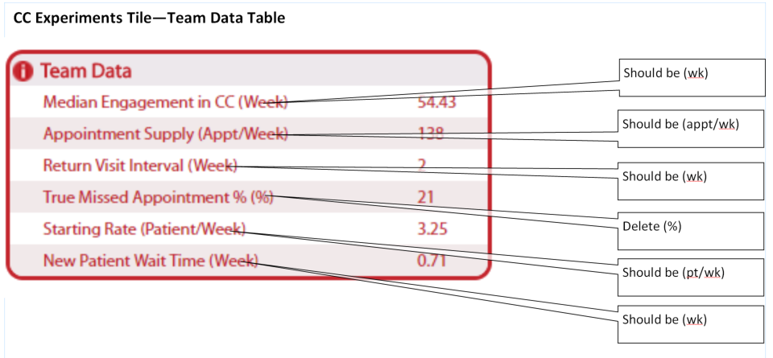

Figure 2

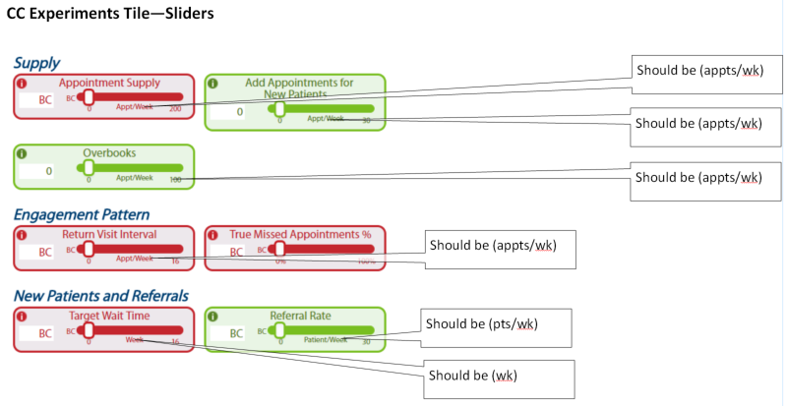

Figure 3

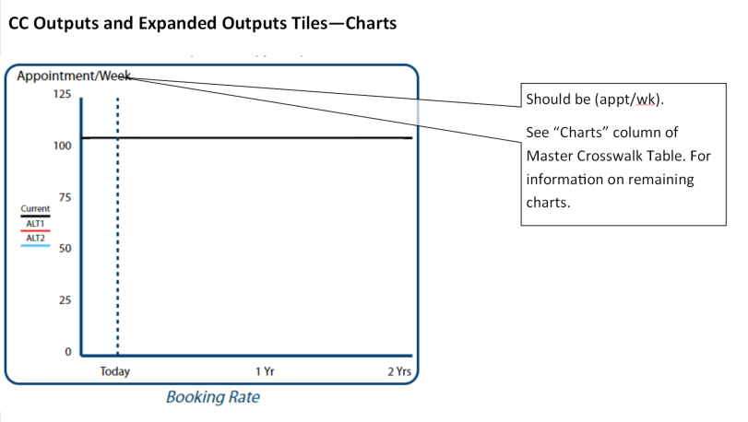

## Standardize AGG Model

1. Refer to Master_Crosswalk_Table_v4_2AUG18.xlsx, CC Tab for variable crosswalk mapping.
2. Items highlighted in purple indicate that a standardization of names is required. The column labeled “Standard Label” is the name to which, all platforms will standardize.
3. The column labeled “Standard Units” is the abbreviation used to indicate the appropriate unit of measure. Exceptions are listed below:
   1. All visual representations of percent will be “%.” The “pct” label is only used for experiment file naming.
   2. If a Standard Label contains a “%” then a unit of measure does not need to be used. For example, “True Missed Appointment %” does not need a (%) in the team data table.
   3. “%” will still be used for scales on sliders, even though the slider title may contain a “%.”
4. The column labeled “Charts” indicate the chart name, preceded by the default order number for that chart in the drop down menu. For example, “6-Starting Rate” indicates the Starting Rate chart will be in the 6th default position. There are 14 default positions for charts in the CC model.

Figure 4

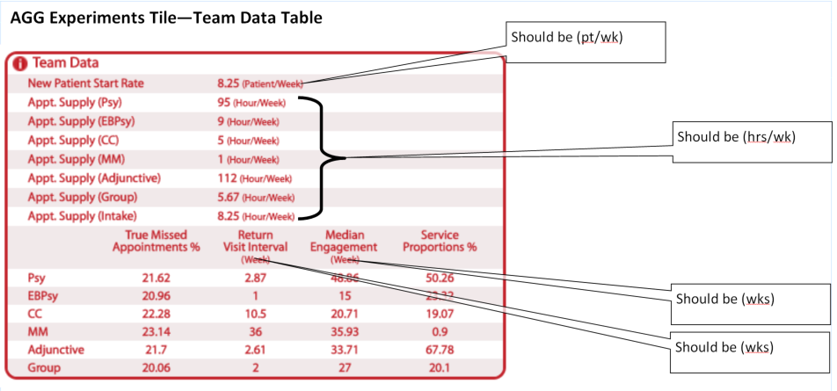

Figure 5

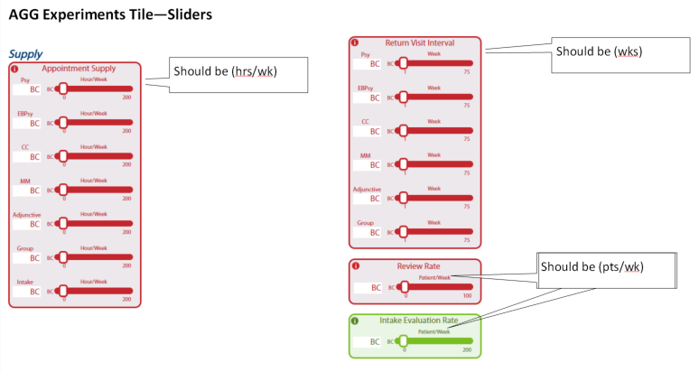

Figure 6

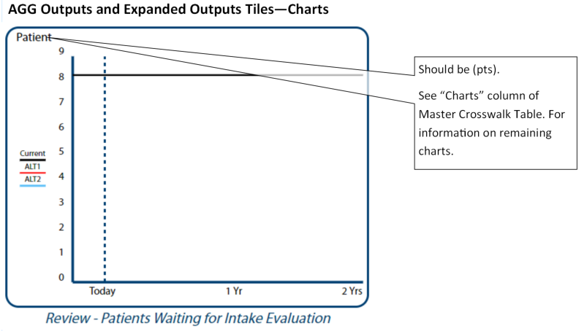

## Standardize PSY Model

1. Refer to Master_Crosswalk_Table_v4_2AUG18.xlsx, CC Tab for variable crosswalk mapping.
2. Items highlighted in purple indicate that a standardization of names is required. The column labeled “Standard Label” is the name to which, all platforms will standardize.
3. The column labeled “Standard Units” is the abbreviation used to indicate the appropriate unit of measure. Exceptions are listed below:
   1. All visual representations of percent will be “%.” The “pct” label is only used for experiment file naming.
   2. If a Standard Label contains a “%” then a unit of measure does not need to be used. For example, “True Missed Appointment %” does not need a (%) in the team data table.
   3. “%” will still be used for scales on sliders, even though the slider title may contain a “%.”
4. The column labeled “Charts” indicate the chart name, preceded by the default order number for that chart in the drop down menu. For example, “6-Starting Rate” indicates the Starting Rate chart will be in the 6th default position. There are 14 default positions for charts in the CC model.

Figure 7

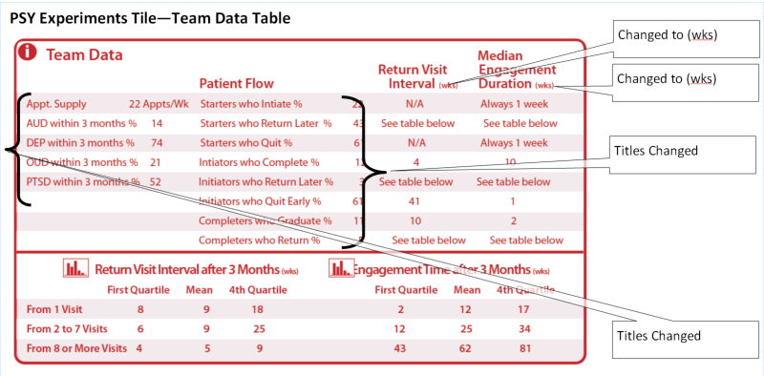

Figure 8

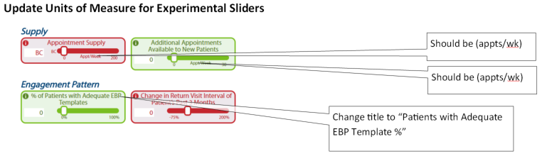

Figure 9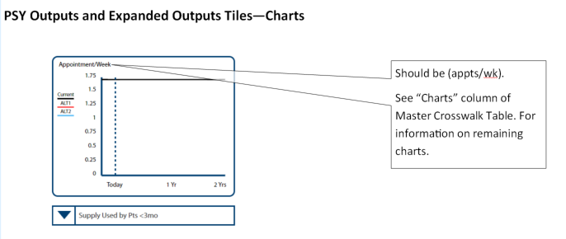

## Standardize MM Model

1. Refer to Master_Crosswalk_Table_v4_2AUG18.xlsx, CC Tab for variable crosswalk mapping.
2. Items highlighted in purple indicate that a standardization of names is required. The column labeled “Standard Label” is the name to which, all platforms will standardize.
3. The column labeled “Standard Units” is the abbreviation used to indicate the appropriate unit of measure. Exceptions are listed below:
   1. All visual representations of percent will be “%.” The “pct” label is only used for experiment file naming.
   2. If a Standard Label contains a “%” then a unit of measure does not need to be used. For example, “True Missed Appointment %” does not need a (%) in the team data table.
   3. “%” will still be used for scales on sliders, even though the slider title may contain a “%.”
4. The column labeled “Charts” indicate the chart name, preceded by the default order number for that chart in the drop down menu. For example, “6-Starting Rate” indicates the Starting Rate chart will be in the 6th default position. There are 14 default positions for charts in the CC model.

Figure 10

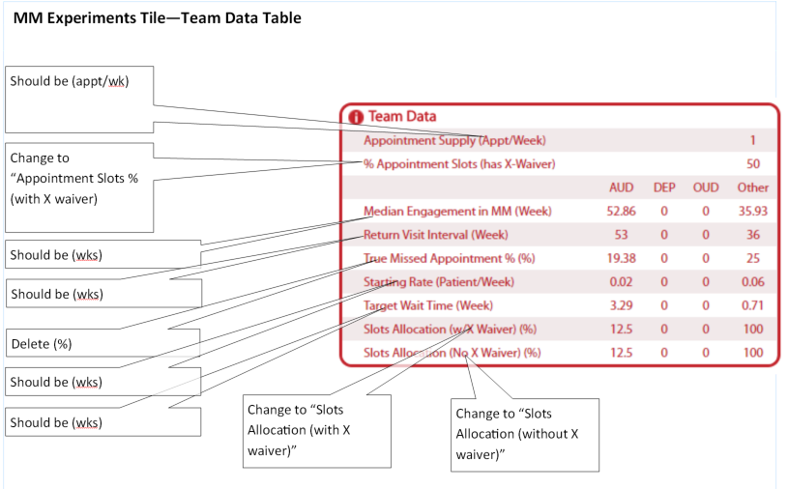

Figure 11

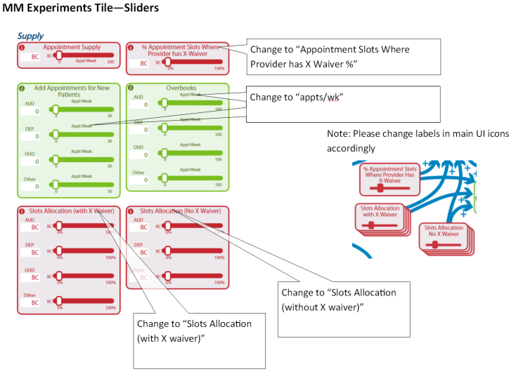

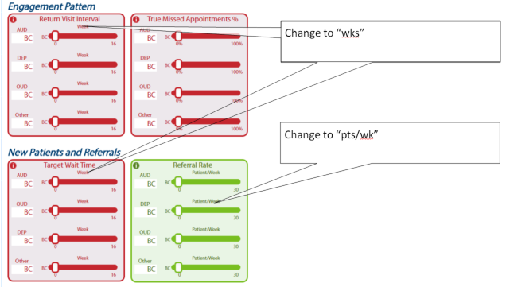

Figure 12

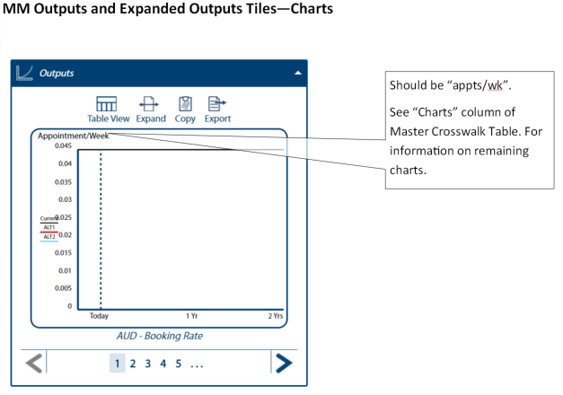

## Update Psy Model Experiments Slider

In the PSY model, provide a box showing the sum of the slider settings in the "New Patients Who Initiate %," Initiators Who Quit Early %," "Initiators Who Complete %," and "New Patients Who Return Later %" Experiment Sliders (See figure 13 below).

Figure 13

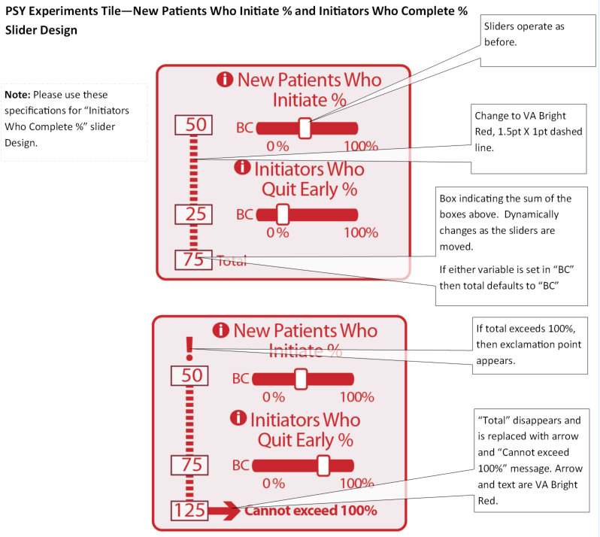

## 

## Add Text from Previous Session to Expanded Outputs Text Fields

Provide option for the user to add text into the text fields of the Expanded Outputs Tile, from previous saved Experiments (see figure 14 below).

Figure 14

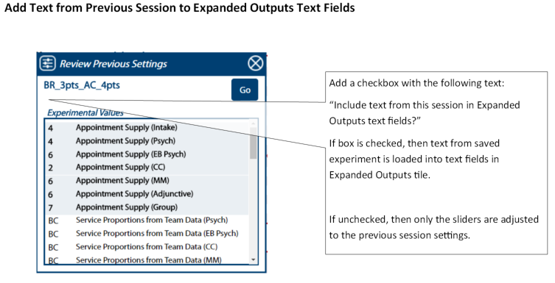

# Testing

MTL Team and Developers will develop and test each model incrementally in the order specified in the development schedule. Developers will release full version 1.6 into Production, when testing of all models is complete in Test.

# Design Questions

We can use this section to ask and address questions.

1. Questions for Developers
   1. Is it possible to run a subroutine that will take experiment data from previous runs and render the charts, prior to a simulation run? Currently, if a user wants to choose a previous experiment for a basis of comparison in the alternative analysis function of the Expanded Outputs screen, the user must run the simulation before the charts will render.
2. Questions for client.
   1. <NA>

# Recordings of Calls

Dial-in number (US): (712) 451-0889

Access code: 110492

International dial-in numbers: https://fccdl.in/i/james_m_rollins

Online meeting ID: james_m_rollins

Join the online meeting: https://join.freeconferencecall.com/james_m_rollins

For 24/7 Customer Care, call (844) 844-1322

join.freeconferencecall.com/james_m_rollins